**Transit’s Positive Effect on Quality of Life**

Throughout the 20th century, car ownership became something to strive for in the United States. Cities were built around the personal vehicles that everyone wanted, making their possession increasingly necessary to get around.

This turned out to be a bad idea.

As it turns out, the shift to sprawling, car-oriented cities had negative effects on quality of life for their citizens. Or, to look at it in a different light, cities that remained reliant on transit experience a *higher* quality of life than those that have fallen victim to the car.

Why is this? A lot of it comes down to transit-oriented cities simply being more desirable places to live…but that desirability stems from the city’s ability to be oriented to transit in the first place. In essence, for a city to be able to withstand a high rate of transit usage, it has to be dense enough to support good transit; that density means it’s easier to walk places and there are more amenities near each home.

Of course, the United States is not known as a transit paradise—there are just ten states (plus Washington, DC) where transit usage is higher than 5%, mostly concentrated in the Northeast and on the West Coast. Besides DC’s impressive rate of 42.8%, New York as a state manages to come out on top, with a whopping 34.3% of commuters using transit to get to work. Unsurprisingly, there is a correlation between transit usage and the rate of no vehicle ownership, suggesting that when people can rely on transit, they do not need to pay the exorbitant costs of owning a car—according to the [American Public Transportation Association](https://www.apta.com/news-publications/public-transportation-benefits/), 93% of household transportation costs in America go toward the payments and maintenance of cars.

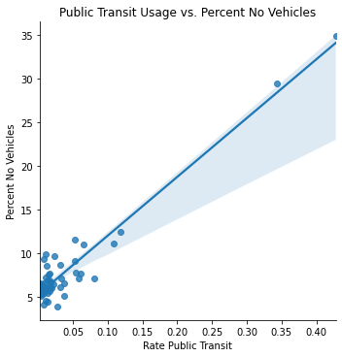

Certain signs from US Census data show correlations between transit usage and signs of prosperity or desirability. For example, contrary to the belief that transit is only used by those who are low-income, there is actually a positive correlation between states with high transit usage and the median income of said states. This seems to attest to the attractiveness of cities with good transit networks, both for residents and for high-paying jobs.

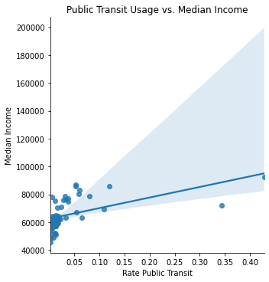

Similar to the income correlation, a similar correlation exists for median home values. This is another sign that transit increases desirability of an area, thus driving up the real estate values.

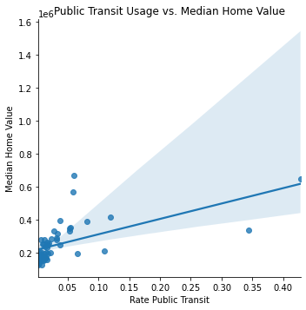

Despite the high incomes and home values of states with high transit usage, though, it may not be encouraging new residents to move in from elsewhere in the country. Looking at a graph of transit usage versus people moving in from other states, there is practically no correlation, suggesting that the desirability of transit cities may be attractive more so to those from the local areas (i.e. people moving from the suburbs back into the city) rather than from other states.

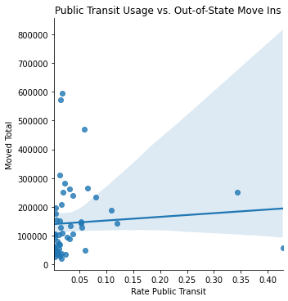

Still, it is clear that transit and the benefits that come from cities that do it well lead to prosperity and a higher quality of life in the places it serves. From a greater density of activities near homes to spurring higher income and home values, a city that can rely on public transportation is a city that will have a better livelihood than one that cannot.